

Identification of key strengths and weaknesses (in terms of skills) of the knowledge transmission methodologies for family industrial SMEs.

Summary report of the main obstacles and difficulties to formalize and transfer of knowledge between generations

Index
The Family Enterprises in the European economic activity ………………..…………..3
A European definition of a ‘Family Enterprise’…..…………………………..………………………3
EU Family Businesses in Numbers……………………………………………….…………...3

Characterization of business environment in Romania, Spain, France and Italy……………………………………………………………….……………………………………………………………………5
Characterization of family business in Cluj County – Romania –………………………………..6
Characterization of family businesses in Bizkaia – Spain – …………………………….………10
Characterization of family businesses in Paca – France – …………………………….…………13
Characterization of family businesses in Veneto – Italy – ………………………………………..17
Identification of the main obstacles to the formalization and transfer of knowledge between generations…………………………………………………………………..…………20
Statement…………………………………………………………………………………………………………….…20
Transmission and Generations…………………………………………………………………………………21
Transmission of Knowledge&Information and Different Generations………………………21
Age-old conflict: Baby Boomers Vs Generation Y…………………………………………………..…23
Who are they? ............................................................................................................23
Management and Generations………………………………………………………………………………..25
Obstacles to the formalization and transfer of knowledge in the Family Enterprises ..……………………………………………..…….………………………………………………………….….28
Transnational Identification of key strengths and weaknesses of the Methodologies Selected for family industrial SME`s……………………………………………32
Bibliography……………………………………………………………………………………………………………………37

The Family Business in the European economic activity.

A European definition of a ‘Family Business Enterprise’

The proposed definition reads as follows:

A firm, of any size, is a family business, if:

(1) The majority of decision-making rights is in the possession of the natural person(s) who established the firm, or in the possession of the natural person(s) who has/have acquired the share capital of the firm, or in the possession of their spouses, parents, child or children’s direct heirs.

(2) The majority of decision-making rights are indirect or direct.

(3) At least one representative of the family or kin is formally involved in the governance of the firm.

(4) The person who established or acquired the firm (share capital) or their families or descendants possess 25 per cent of the decision-making rights mandated by their share capital.

This definition was first issued by the Ministry of Trade and Industry of Finland in 2006.

EU Family Businesses (FB) in Numbers
Nowadays, there is a general consensus about the significant contribution that family businesses make to the growth and the economic development. The participation of these companies to create jobs makes them one of the engines of the economy in Europe.

In the past few years, family businesses have seen dramatic changes in their business environment. Besides navigating perpetual challenges such as wealth inheritance and transfer, nowadays family businesses in Europe must adapt to changing capital markets and deal with emerging competition in a globalized world.

There are around 17 millions de FB, that means 75% of the companies in the EU.

• They employ 45 million people.
• They represent 65% of GDP and employment.
• 25 of the 100 largest European companies are FB.
• There are 200 family businesses in the 1,000 top European companies.
• Family firms represent 76% of UK companies, 70% Portugal, 75% in Spain, 67% in Switzerland, 90% in Sweden, 83% in Austria, 69% in Belgium, 93% in Germany, 63% in Finland, 61% in France and 95% in Italy and Eastern Europe.

% Workers GDP Contribution

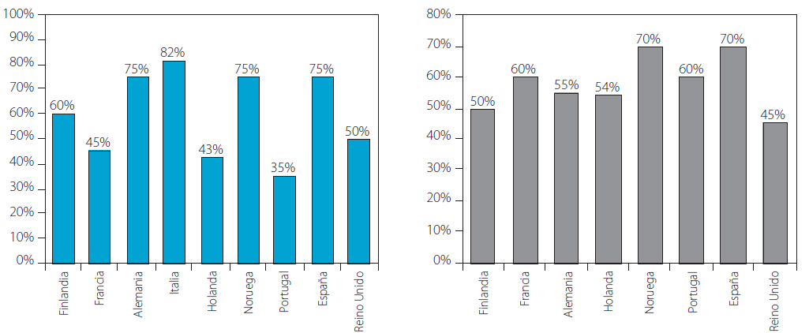

European Group of Owner Managed and Family Enterprises - Chamber of commerce of Biscay

Characterization of business environment in Romania (Cluj County), Spain (Biscay), France (Paca) and Italy (Veneto).

Characterization of family business environment in Cluj County – Romania

In Romania, between December 1990 – December 2007, 439,993 family businesses and freelancers were registered. This value represents over a quarter of the number of registrations at the national level (1,700,635) and over a half of the number of Small and Medium-sized Enterprises (SMEs) (700,000) that are active in the Romanian market.

The structure of national economic activities that involve most of the family businesses is the following:
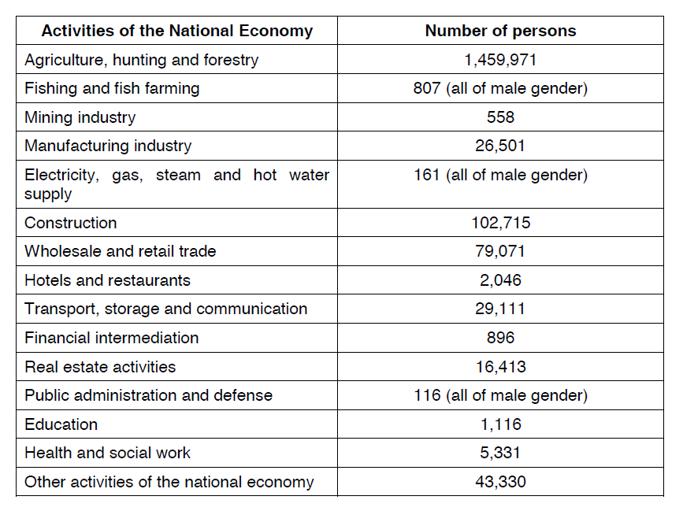
European Commission - Small and medium-sized enterprises (SMEs)
Family business - reference documents

Cluj County
Overview
Cluj County is part of the North-West Development Region of Romania which covers an area of 34,159 km² representing 14.3% of the total country. The region consists of six counties (NUTS 3): Bihor, Bistrita-Nasaud, Cluj, Maramures, Satu Mare and Salaj. Around 12.6% of the total population of Romania is located in the North-West Region. Cluj County stands out as the main financial and industrial area of the region.

Sustained development in recent years is due to consistent foreign investments and the development of public and private industrial parks, especially those located in the vicinity of Cluj-Napoca.

According to the latest Trade Register Office statistics nearly 51,000 companies, representing 5% of the total registered companies in the country are operating in Cluj. Another set of data provided by the above mentioned organization registers 312 companies active in the metal sector.

Size
The business structure in Cluj County is mostly made up of SME`s, but there is a reasonable number of large enterprises, which have more than 250 employees and are operating in the industry and services sectors (Transylvania Bank – around 5.500 employees in 2010, Transylvania Energy Company and so on).

The largest operator in the metal sector, with around 2600 personnel, is located in the city of Campia-Turzii. It has been traditionally a large siderurgical complex and it is controlled by Mechel International Holdings Gmb, its main shareholder.

Of the total number of companies active around 3% are large companies, with staff over 250. The rest are medium, small and micro enterprises. The tendency is toward medium and small enterprises in the metal sector, with the percentage of micro enterprises just under 20%.

The number of employees has declined yearly, in all types of enterprises, due to the financial crisis.

Seniority

It is important to understand that none of the private enterprises in Romania are older than 21 years. During the previous regime all enterprises were nationalized and concentrated into large industrial complexes. In the metal sector, two poles were prevalent in Cluj County, during that period: Campia -Turzii Complex which was producing wires, cables, tubes, nails and so on and the Heavy Machinery Complex of Cluj-Napoca (CUG), which was producing heavy machinery and other metal products.

After 1989, Romania has made considerable efforts to privatize state enterprises, including large ones. They were sold to foreign or domestic investors on the whole or in part. Most existing private companies, including familial SMEs, were created on the skeleton of large industrial complexes. In many cases, these SMEs have inherited the production techniques and equipment of their “ancestors”, which are currently worn off and not cost effective, making this firms status very vulnerable.

So these companies need new and innovative systems to facilitate the transfer of knowledge between all groups of staff active in the company and need a professional training system on the job and a lifelong learning system in order to maintain their competitiveness.

Employment

Cluj County economy has shifted from an industrial profile toward a services based economy.

Before 2008 the unemployment rate stagnated at 3%. As the crisis affected more and more companies, the unemployment rate raised to 6%. In the last quarter of 2010 the unemployment rate dropped again to 4%.

The metal sector companies were especially affected. Though the building industry decline was more dramatic, metal companies have seriously reduced their personnel in order to stay afloat.

Active Civilian Population in Cluj County: 330.000
Employed Labor Force as of July 2010: 192.555 persons

Distribution of Companies by economic Sectors
Cluj County has one of the most dynamic economies in Romania. It is a region with one of the highest ratings of foreign investments. In addition, Cluj-Napoca is home to one of Romania's important IT and financial services centers.

The county's main industries are:

- Mechanical components;
- Wood processing;
- Glass manufacturing;
- Pharmaceutics and cosmetics;
- Food stuffs processing;
- Textiles.

Mining and natural gas extraction are also developed.
Metallurgy and metal products have a share of 6.1% of the local economy.

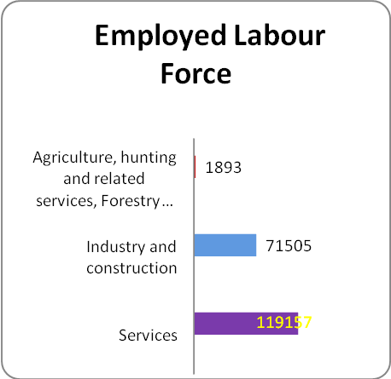

Data in this graph was provided by National Institute of Statistics – Directorate Cluj

Export Activity

Goods exported from Cluj include: telephone and electronic equipment, paper and paperboard, articles of apparel and accessories, knitwear, footwear, iron, iron and steel, boilers, machinery and mechanical appliances, machinery and electrical equipment and parts, furniture.

A successful survival strategy applied by most foundries in Cluj is to find a foreign contractor, from the European Union, which pays its contracts in EUROs and regularly awards them contracts. The Cluj Chamber of Commerce and Industry has been involved in this endeavor, supporting the companies by organizing matchmaking sessions and trade missions with potential foreign partners.

Companies in Cluj are quite adaptable and flexible as long as their technology allows, offering their clients cost effective products. It is possible to do just that because the wages in the industrial sector are low, thus the production costs are mostly influenced by the cost of the technology used.

Roots in their environment

Familial SME`s do not have the necessary financial capacity and know-how in order to establish a presence abroad. A reasonable number of the companies now active in the metal sector are established by foreign investors. The overall privatization policy of Romania was to attract foreign investments.

Characterization of family businesses in Bizkaia – Spain -
It is worth stressing that the largest share of enterprises operating in Spain can be regarded as family businesses. Thus, and according to some estimations provided by the instituto de Empresa Familiar, in Spain there are currently around 2.8 million enterprises (out of a total of 3.3 million enterprises in Spain), where these enterprises generate a 70% of the total Spanish GDP and employment for nearly 13.5 million people (around 75% of the total Spanish private employment) (Instituto de Empresa Familiar 2007 - Family Enterprises Institute, 2007).

The Instituto de Empresa Familiar also estimates that approximately a 65% of the Spanish family businesses are in the first generation, whereas 25%, 9% and 1% are in the second, third or fourth or more generations, respectively. Interestingly also, the Instituto de Empresa Familiar also provides some socioeconomic data on those family businesses associated to this Institute (usually very large and important family businesses in the Spanish economy). Thus, the 104 family businesses associated to the Instituto de Empresa Familiar represent a 15% of the total Spanish GDP, and they provide employment to more than 70 thousand people, where 60% of the associated enterprises have more than 1,000 employees. The sectoral distribution of these associated enterprises is the following one:

• Services 9%
• Manufacturing 1%
• Food and Beverage 27%
• Construction 16%
• Media 7.5%
• Financial Institutions and Insurance 5%
• HORECA 7%

The comparison with the national average shows a larger presence of associated family businesses in the food and beverage sector (27% in comparison to the 0.9% that they represent in the total number of Spanish enterprises), in the financial and Insurance institutions (5% in comparison to the national average of 1.8%) or in the media sector (7.5% in comparison to the national average of 2.3%).

Bizkaia
Size

The business structure in Biscay is mostly made up of small productive units (the 99.82%) which the vast majority is family-owned. 91.71%% of the firms analyzed are small companies between 10 and 49 employees. If we consider the set of small and medium enterprises, between 10 and 250 employees, the figure rises up to 99.17%. Big companies with more than 250 employees, don´t reach 1%.
With this numbers we can appreciate that influence in our economy of the familiar companies is more that important.

Seniority

73.80% of the companies are more than ten years old. That is, around three quarters of the companies in the sample analyzed are visibly established in the Biscay business structure. However, just the 2% of family companies are more than 55 years old, which supports the general idea that very few companies go beyond the second generations change, maintaining the family character.

Employment
The largest contribution to employment of family companies in Biscay comes from entities that are already established in the market, with more than 20 years old and at a critical moment in the generational change, in generational terms speaking. These are the companies with the highest risk of losing their family character, precisely those that make the greater contribution to job creation in Biscay.
Sector Distribution
The Biscay family companies activity is mainly concentrated in three sectors: "Extractive industry" with 36.65%, 'Construction' with 22.39% and "Production and distribution of electricity, gas and water" with 16.25%. At some distance are three other sectors, which represent approximately 5% of the family companies respectively. These are the cases of "Trade, repair of motor vehicles, motorcycles and personal and household use articles ',' Hotel industry 'and' financial intermediation." They are mature sectors with a low technological and innovation level, and some of them show certain grade of fragility, either structural, or cyclical.
In the Metal Sector the distribution of companies can be established by the next distribution (Activity – Number of companies):
Metallurgy Industries and First Transformation 115
Metallic Products 468
Machinery and Equipments 329
Electronic and Electric Materials 111
Transport of Materials 85
Services 132
Constructions Works and Installations 159

Export activity
Less than 20% of the companies sell some of their products abroad, particularly, only 18.6%. The fourth part of the turnover of family companies which export, comes from sales carried out abroad, more precisely, 24.32% of the yearly turnover. Family firms that export are small companies that, despite their limited size, have made a commitment in favor of the internationalization and their aperture to new markets. These companies with international presence are settled in Biscay since many years.
Roots in their environment
The familiar companies are strongly rooted in Biscay, since only 12% of them intend to move the business or part of it abroad.
Additionally, the main reason why family companies are willing to transfer all or part of the business out of Biscay, must be understood from the point of view of the expansion strategy of the company (almost 50% of cases). This strategy does not seem to endanger the continuity of the business in the Territory. In fact, it represents a new source of wealth generation, provided the headquarters of the company continue staying in Bizkaia.

Characterization of Family Businesses in Paca – France -
The importance of family businesses in the French economy depends of course of the definition adopted as shown below.

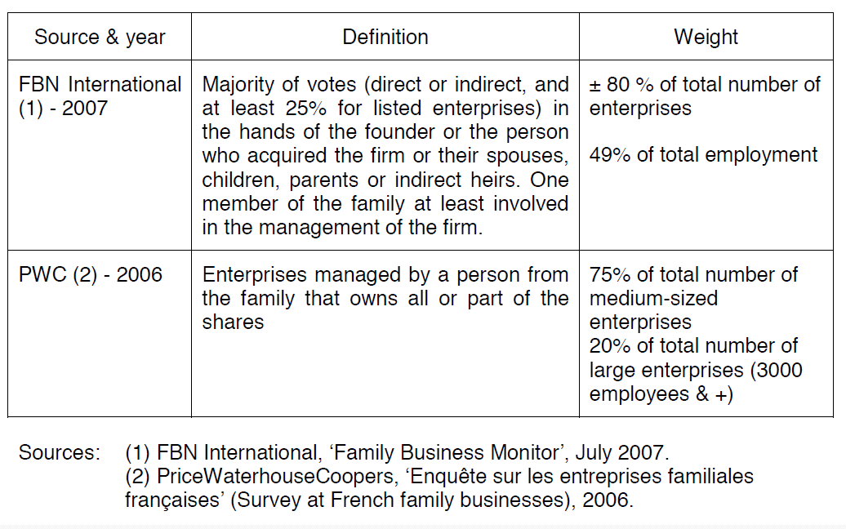

As regards size-class distribution of family business, it must be stressed that family businesses are not only SMES, they do exist in all size-classes.

A study on the 500 French largest private enterprises in manufacturing industries showed that the part of family owned enterprises increased from 47.6% in 1982 to 49.2% in 1992. Another study, concerning enterprises listed on the French stock exchange between 1994 and 2000, revealed than one-third were controlled by the founder and another third by heirs of the founder.

Paca
Size
The business industrial and building structure in PACA (Provence Côte d’Azur) is mainly made up of SME: about 75 000 companies (INSEE Survey 2008).These companies employs 282 214 people dispatched between 2 sectors: Industry and Building (see below).
About 1100 Metal companies are members of IUMM (Union des Industries et des Métiers de la Métallurgie) which is a specific trade union. According to its figures the regional companies’ have the following size:
◻ 0 to 50 employees 47%
◻ 51 to 100 employees: 23%
◻ 100 to 250 employees: 30%
Around 50% of the companies employ between 10to 40 workers. One out two workers belongs to an enterprise with less than 50 people so we are faced to a family enterprise structure.
Seniority
The oldest companies (7%) were founded in 1945.
18% between 1946-1975
19% between 1976-1985
31% between 1986-1995
25% between 1996-2005
The seniority of the companies is quite high : an average of 25 years old. Most of them have been established during the last 20 years
1 out 4 has been created before1976. Insofar as 7% of Metallurgy companies are more than 60 years old that strengthens the opinion that a SME doesn’t last over 2 or 3 generations.

Sector Distribution
The Metal industry sector in PACA is mainly concentrated in:
- Metal manufacturing (46,3%)
- Machine manufacturing (34%)
- Foundry: 19%
Different production process:
Most of these companies deal with production: mass and short production and tailor made production and they propose also service on a specific trade.
The more the company’s size decreases, the more it produces short production or tailor made production.
Within the Industry family the main sectors are mainly concentrated in the following ones (INSEE Survey 2009):

Industrial Metal Sectors | Number of companies | Number of employees
Extractive industry | 276 | 1 662
Metallurgy and metal products manufacturing | 1 548 | 14 563
Other manufacturing industries(repairing) | 6 562 | 19 929
Machining manufacturing | 590 | 5 670
Wire drawing industry | 274 | 2 697
Production & distribution of electricity, gas &water | 1 159 | 11 512
Building Sector | 50 632 | 119 290

Export activity:
The majority of the Metal industry companies are subcontractors for big companies. Their activity is closely linked. Globalisation and the relocations towards abroad hit the principals and the subcontractors.

Roots in their environment
Their relationships with other regional industries as agricultural mechanics, food industry, nuclear industry, petrochemistry, chemistry, construction, electronics....) or with high technology (aircraft and space.....), their abilities with export market makes an essential link within the regional economy and require to be interested in their needs for skills.
Some important factors observed underline:
- An ageing working population and large-scale renewal of working populations.
- The need to build up some parts areas of knowledge, experience and know-how
to pass it to on future generations.
- A rapid technological and organisational changes in companies making the companies and their workers vulnerable.
If they can’t overcome these problems their survival is really threatened.

Characterization of family businesses in Veneto – Italy -
The industrial structure of Italy includes a large number of small, medium as well as big family enterprises (the well-know are Pirelli family, Benetton family, Agnelli family for the Fiat, Barilla family as well as Ferrero family). The ownership of most Italian firms, even large ones, is tightly held, frequently by a single extended family. Family members frequently take an active interest in the day-to-day operations of the typical firm. Furthermore, Italian companies are members of a hierarchical relationship with interlocking ownership and concentrated control called a “pyramidal business group”. These groups are typically headed by a parent company that holds controlling stakes directly or indirectly in member firms. Each company within the group, however, remains legally independent. Several explanations have been proposed for the existence of these groups4. The group structure allows the parent company to control a large amount of assets with minimal investment. Thus, groups allow for leverage and diversification. An additional reason for the formation of groups is that they may help to establish internal capital markets.

In general, Italian enterprises are exposed to high competition ever more than in the past to the challenges of market globalisation. They have changed over time. It is caused by structural and fiscal Italian problems, low flexibility of labour market, inadequate competitiveness of product and services markets, an unbalanced specialisation towards traditional sectors not dynamic at global levels, inadequate investments in human capital as well as research and development of technologies. Businesses are more concentrated in the north of Italy then in the south. Generally, Italian enterprises are small sized and they growth slowly with a low profitability. Their presence is insecure in the product and labour markets.

Veneto
Size
The structure of SMEs in Northern Italy shows a considerable number of family businesses (around 80% with variations depending on years of activity and geographical areas), a relatively moderate strategic complexity (there is only one strategic line of business in more than half of cases analysed, and only one enterprise in ten has more than three lines of activity), and the strong predominance of functional organizations (about 70% of enterprises), but still with a somewhat successful implementation of the matrix structure (15-20% of cases). The presence of a Management Control Function is not deeply-rooted yet (about 50%).
The Board of Directors operates in the large majority of enterprises (between 72% and 97%), with the massive presence within it of the owner’s family members. The presence of the family still pervades the aspect of governance, by definitely occupying in many cases functions such as that of Chairman or Managing Director (constantly more than half of functions analysed, with record percentages of 88% for Chairmans appointed among the family members), whereas this is less the case for managerial positions requiring specific technical knowledge. To quote an example, the Chief Financial Officer is a family member only once in three cases.
The entrepreneurial structure in Veneto is characterized mostly by family-run businesses, whose history is the same as that of their founder. This type of enterprises developed mainly in the 1960s and 1970s, owing to the conjunction of different factors such as the propensity to risk, the self-entrepreneurship of many people, the availability of skilled labour and expanding markets. The social fabric of Veneto, too, has contributed to supporting enterprises, by providing education and qualified skills learning opportunities, as well as a low degree of social conflict and a family model being able to adapt to the company’s needs.

There are currently 506,000 enterprises in the Veneto Region, of which 95.5% are SMEs. The total number of active companies is 457,225 , of which 58,260 are manufacturing companies. Family businesses are scattered across the different sectors in the following way: 4% in the food sector, 18% in fashion and design, 14% in wood and furnishing, 13% in chemical and plastic products, 37% in the metalworking sector, and 14% in other activities.

Active companies sorted by sector - Veneto, 1st quarter 2009 - 4th quarter 2010
 | 1st/2009 | 2st/2009 | 3st/2009 | 4st/2009 | 1st/2010 | 2st/2010 | 3st/2010 | 4st/2010 | Var. betw. 4th/10
Agriculture and fishing | 82,418 | 82,288 | 82,042 | 81,353 | 79,89 | 79,952 | 79,737 | 79,07 | -2,282
Manufacturing | 60,378 | 60,09 | 59,69 | 59,166 | 58,661 | 58,62 | 58,481 | 58,26 | -906
Construction | 75,677 | 75,709 | 75,646 | 75,211 | 74,485 | 74,711 | 74,763 | 74,566 | -645
Services | 237,915 | 239,712 | 240,648 | 240,466 | 240,638 | 242,607 | 243,368 | 243,651 | 3,185
Other act. | 2,306 | 2,271 | 2,253 | 2,156 | 2,202 | 2,2 | 2,182 | 1,677 | -479
Total | 458,694 | 460,07 | 460,279 | 458,352 | 455,876 | 458,09 | 458,531 | 457,224 | -1,127
Total excluding agriculture and fishing | 376,276 | 377,782 | 378,237 | 376,999 | 375,986 | 378,138 | 378,794 | 378,154 | 1,155

Changes which occurred between 2002 and 2009 on the corporate capitalization structure reflect the ever increasing influence of limited companies to the disadvantage of family companies. Active companies sorted by size of capital stock are classified as follows:

no capital stock | 263,643
Up to 10 mill. Euros | 59,921
10-25 | 76,179
25-100 | 37,316
100-500 | 12,966
>500 | 8,327

The internationalization process has caused two main types of consequences: a few sectors have been interested by concentration processes by means of mergers and acquisitions giving birth to medium- or large-sized companies, others have seen a shift of the competitive focus from the companies to the production chains. In an economy characterized by small and medium-sized family companies, the “group” structure has offered the organizational solution in order to manage and lead dimensional growth. Groups are a type of business organization allowing dealing with dimensional growth, to find resources and financing methods, while maintaining at the same time the exclusive right of control. The family dilutes the ownership shares and involves external financiers, without giving up the opportunity to imprint its management philosophy. Small and medium-sized family businesses are a large, widespread group in the Veneto region. Companies belonging to a group, with the distinction between the parent company and the subsidiaries, amount to 18.5% of the total figure, with 6.5% of parent companies and 12.2% of subsidiaries. In 54% of cases the reference partner is also the leader of the company around whom the core of activities is centred, whereas in the remaining 46% of companies the leadership is taken by a different person. This means that almost half of companies experienced the process of transfer of the entrepreneurial leadership.

Identification of the main obstacles to the formalization and transfer of knowledge between generations
Statement
The progressive ageing of the working population, the difficulty in the transmission of professional knowledge and the continuous changes within companies (the introduction of new technologies as well as the retirement of increasingly older workers) are some of the elements that have made knowledge management become more and more important in the society.
Between 2000 and 2025, the population will increase by 9% in France (+ 4 millions).The oldest (more than 80 years old will pass from 2.7 millions in 2000 to 4 millions in 2020 and 6 millions in 2040. The part of the 60 years old people and more will pass from 21% in 2005 to 25.3% in 2015, then to 31.1% in 2030.This state involves a reduction of its ageing and working-age population. Demographic projections emphasize the gradual reduction for the age bracket 20-59 years. After 50 years of stability (53.7% in 1950, 53.8 % in 2000), this age bracket has lightly spread until in 2005 (54.3%). According to an article headed « Projection de la population active à l’horizon 2050 » by INSEE Première (2001), n°762, mars, this decrease could reach 51.5% in 2015, 48.9 % in 2025 et 44.8 % in 2050.
So, the French working population has been changed since 2007:(what does this word mean) of the young workers (- 800 000 for the age-bracket 20-29 years old from now to 2025), and expert ones (- 1.6 million for the age-bracket 30-49 years) and an over abundance of the seniors (+ 3 million for the 50-64 years old).

Consequently, companies begin to be short of workforce in spite of experienced workers, who concentrate important knowledge. But the workers are going to retire and companies are facing new workers (or future ones), usually with high theoretical knowledge but without much experience, needing a quicker and more flexible adaptation to the new working situations and in particular to company organization, culture and structure.

All this makes it is necessary to transmit knowledge between generations. Knowledge transmission is an important contributor to the survival and development of companies in the present changing context and for improving their competitiveness.
This paper aims at placing the intergenerational transmission problem in the context of organizations, considering the different generations who are going to live and work together and identifying the obstacles to the transmission and transfer of knowledge between them.
Transmission of Knowledge&Information and Different Generations
Transmission of information plays a central role in shaping human knowledge. Some of the most complex knowledge that people acquire- such as languages or cultural norms, values, norms, beliefs…- can only be learned from other people, who themselves learned from previous generations. So, intergenerational transmission is one dimension of the larger concept of intergenerational relations. The term intergenerational relations describe a wide range of patterns of interactions among individuals or generations. The term is also frequently used to describe behaviors involving older and younger people in society at large, even if they’re unrelated to one another (for example between those in older generations such as parents and grandparents and those in younger generations such as children and grandchildren). The presence of intergenerational transmissions has strong implications for public policy but also for economic policy.
Descriptions of Generations
Sociologists have always been interested in the generations as they traverse time. The concept of ”generations” is used to characterize groups who developed some characteristic values, attitudes, preferences, and behaviors. A generation defines a group of individuals in a given context together who share the same history and relatively similar experiences. Each generation has its own distinct set of values that is developed from the social environment in their early years. Different generations have different values and beliefs regarding family, career, the work/life balance, training and development, loyalty, gender roles, the work environment and expectations of leaders. Defining the generations is itself an imperfect science. Five types of generations have been distinguished since the Second World War (Anne BOURHIS, 2006). Demographers have named the different generations around today as:

- the Veterans/Seniors seniors born before 1946
- the Baby Boomers born between 1946 and 1963
- Generation X born between 1964 and 1977
- Generation Y born between 1978 and 1992 and lastly,
- Generation Z born after 1993.

They share a certain number of practices and representations owing to having the same age and belonging to the same epoch. Each has a different communication need, based on their lifestyle characteristics, dress code, and personal communication. Each generation has a distinct set of values, view of work environment and those they do business with.
The following table shows a short description of 3 generations, based on Eisner (2005) and Dries, Pepermans & de Kerpel (2008).

Generation (born) | Formative experience | General values/ qualities | Work values
Baby Boomers  1946-1963 | Post-war prosperity  Largest generation  Anything is possible, prosperity | Loyal, tolerant, creative, self-absorbed, optimistic, idealistic | Workaholic, innovative,  materialism
Generation X  1964-1977 | Globalization, economic crisis, latchkey kids, divorces, downsizing | Sceptical, less loyal, individualistic, entrepreneurial, flexible | Materialism, balance, self-supporting, work-life balance, fun, want constant feedback and rewards
Generation Y  after1978 | Prosperity, uncertainty,  terrorism, structured life/live at home, internet, strong social  pressure | Balance, collectivism,  confidence, civic mindedness, learning, shared norms | Passion, demand respect, work to live, challenge, look  to have an impact, want even instant feedback and rewards.

These 3 generations form the workforce at the moment. The purpose of our topic is to look more precisely at two of these generations: the Baby Boomers and Generation Y. Can different generations co-exist effectively in the same workplace? It was said that understanding generational values and how these values developed can help businesses and organizations better manage and perform across generational boundaries. To consider the values and behavior of people today, means taking an interest in the concerns peculiar to the different generations and the needs and expectations they express.
Several studies indicate that the majority of generational conflicts arise from value differences. As this third generation enters an already changing workforce, the stage for conflict is set.
Age-old conflict: Baby Boomers Vs Generation Y
Who are they?
The expression “Generation Y” means persons born between 1980 and 1992. Invented in 1993 by the magazine Advertising Age, the expression “Generation Y” designates the generation following “Generation X”. Other expressions are commonly used to refer to this generation. In particular, they are called “Echo as many of them are the children of baby-boomers or “Children of the millennium”. Americans also use the expression “Digital Natives” to underline the fact that these children were born with a computer or quite simply the diminutives “GenY” or “Yers”. Generation Y is recognized as being seriously predisposed for everything concerning ICT and these people are also called “E- Generation”. In France the generation Y comprises about 13 million persons nearly 21% of the population (INSEE – Institut National de la Statistique et des Etudes Economiques National Institute for Statistics and Economic Studies). It is the most numerous generation since that of the baby-boomers. It is the fastest growing segment of today’s workforce. In a context of retirement age population replacement, studying the generation Y has become essential for business and its future.
Generally, the members of generation Y have individualistic, consumer, inventive and zapping behaviors (Laize, Pougnet, 2007). It is very important and useful to identify their relations with work and Enterprises. The Baby Boomers tend to be disciplined, respect law and order and they like consistency. This generation is not comfortable with change. They have fixed views on the role of each, and in the workplace are comfortable with a directive, command and control management style. Whereas the baby boomers lived to work (their job status and social standing are important, they tend to be optimistic, ambitious, and loyal and believe that employment is for life creating the concepts of “workaholic” and “superwoman”) the Ys work to live. Generation Y has changed its way of life fundamentally. They seek the best possible balance between professional and private life, being quite prepared – if need be - to change work and region to keep this balance: “As for me, what counts is work of course but my personal life too. I couldn’t care less about working where I studied so long as I can find this balance”
This is one of generation Y’s characteristics: they are avid for novelty; “What I want is to get around – something new – and I don’t want to be bored by my work or else I’ll leave.” In their professional or private sphere they fight against routine and search for new things to feed their adaptive capacities. They're programmed to seek jobs that offer the opportunity to learn and grow. These various elements of ways of life concern the sphere of both private and professional life. Generation Y is the generation of change: it has no fear of the uncertainty inherent in it. Consequently, it is difficult to keep this generation’s loyalty, both in the enterprise and its consumption habits. Change is a particular feature of this generation; which is explainable by the economic and social context. ”They create change, going from one brand or job to another. They flourish in ambiguity and uncertainty - environments in which many baby-boomers are not at home at all.” (Chaminade,2007). Some statistics reveal that Gen Y’ers will change often jobs. They have great expectations of their employers. They seek out new challenges and are not afraid to question authority. They want meaningful work and a solid learning curve.
They don’t exactly come empty-handed to the workplace. They bring expert-level computer skills and entrepreneurial drive, but they also expect to be compensated for such drive and skill. They're coming out of college with high expectations for job responsibility and advancement. But in a tight job market, they're competing against the Baby Boomers for the same jobs and advancement.
They perceive human relationships especially through computing and digital tools.
These individuals have grown up with the popularization of the personal computer. As a whole, the communication media match the generation Y’s need for instant expression. Furthermore, generation Y has a strong sense of community identity, comparable to tribes. The “Ys“ say what they think more directly and spontaneously than their elders
Generation Y’s behavior at work is often summed up as follows: “they want an interesting, evolving, formative job, but reject routine, boredom, and restrictions” (Laize, Pougnet, 2007). According to a study by the APEC (Association pour l'Emploi des Cadres – Association for Managers’ Employment) in 2009 work is a value supporting personal fulfilment for the under 30s. In this study some interviewees revealed: “Of course, I want to have an interesting job – it’s important for my well-being and those who believe that we young people couldn’t care less are wrong.” “I shall never choose a job that bores me, it must change and move.” “As for me, work isn’t my life; it’s important, of course, but do you think someone who isn’t happy can be happy in his work? The time when only work counted is over.”
This generation has a certain conception of life and relation to work. Work, in fact, is not the only reference in their universe and the sole reference value; one is quite prepared to accept work is not the only source of fulfillment and well-being. This need for liberty also makes for harsher relations with elders.
In relations with power and line management the elements are also quite characteristic. Generation Y is aware of the importance of making a commitment in professional life, especially at its beginning. Accordingly, they generally express deep respect for their superiors, not for their hierarchical position but for their skills and expertise. Thus, it is not rare to observe that this generation can openly and directly express its criticisms of line-management. So it is thought that this generation’s respect for their hierarchy is not a given but acquired throughout their experience in the enterprise in so far as it allows them to consider this hierarchy is legitimate. They insist on working WITH and not FOR somebody.
Various issues arise in the light of the points expressed and are connected to the enterprises’ HRM systems. Thus, the questions of recruiting and attractiveness are still essential but those relating to career management, training policies.
Management and Generations
A labor shortage is foreseen and organizations will increasingly come face to face with recruitment, intergenerational management (Anne Bourhis, 2006), and employee loyalty problems: “highly informed and naturally prepared for the new technologies this generation Y is also an opportunity for enterprises. Faced with the challenge to renew their workforce– which in France will come to a head from 2010-2015 - recruiters are racking their brains working out how to hire them and keep their loyalty” (Marine Relinger, 2008). Today, companies’ management must evolve a new style inducing the adoption of new management tools, practices. Many human resources managers admit to having difficulties in implementing HR practices for young people (Laize, Pougnet, 2007). A new element of diversity is being addressed: the management of multigenerational teams. Although the multigenerational team has always existed, project performance is being affected but misunderstood perceptions about team members’ conduct. The challenge is to reconcile generational behaviors and values to create the required project synergy.
Project teams include members from four different generations (Veterans, Baby Boomers, Generation X, and Generation Y).

In other words, thinking about what this generation expects and needs entails the issue of renewing the human resources management systems inside the enterprise; rethinking how a business is to recruit, integrate, keep loyal, remunerate, and plan the careers of members of this type of population becomes essential. This generation Y has many characteristics and values that allow a better grasp and understanding of how it relates to work and the enterprise.
On this subject, in academic circles, the emergence in management sciences can be observed of a new managerial tendency that favors benevolent intraorganizational management responding to the expectations expressed by employees of every generation. This element is interesting in so far as it matches the aspirations of generation Y concerning the desire to integrate with and trust colleagues and the enterprise. The members of the generation Y need to have a global vision of the enterprise’s personalities and processes or management systems. This point accords with what this generation looks for: autonomy and being treated as responsible. To do this, it is necessary to have a thorough knowledge of the organization – of its key figures and how it works. Thus, this search for meaning through better grasp of information - a search for trust and social connections - is sought by this generation, and the style of management must take an interest in it. One of the motivations for team work lies in the fact that a Y gives great importance to being able to learn constantly, which can materialize during project group exchanges. The generation wishes to take part in projects to develop new skills. It should be noted that the training is central to the systems for integrating young people. This generation is often seen as less committed or less motivated by work. But looking at things differently means accepting the idea this generation is motivated in another way. Thus, those who think they are less committed are mistaken.
Following the studies of Jacob and Harvey (2005), it is discernable that adaptations are necessary for taking into account the differences potentially existing between generations from the point of view both of managing induction, the work itself, and productivity and of managing commitment, professional development, and conflict management.
Managing generation Y imposes intergenerational management on companies. At the same time, generations Baby boomers, X, Y are in the organizations. Thus, the issues managers face tend to be how to prevent conflicts that may arise between generations and the feelings of unfair treatment that may be perceived between these generations.
Therefore, management systems must be oriented towards managing knowledge and especially the issues connected to its transmission. Mentorial or tutorial practices will enable enterprises to assure the connections between these generations. Preparing new managerial behavior is becoming important. This explains why certain companies develop mentorial and tutorial practices so as to reconcile these generations and create a social bond between them; especially when baby boomers or Xs/Ys are called upon for this type of activity. The generations must not be shown in a systematic opposition within the organization or stigmatize them but it will be better to adapt management systems that facilitate links between these different categories.
Thus, the transmission of the knowledge contributes to the development of the people and dimension of training and lifelong learning in the organizations. But knowledge and skills transmission, or more exactly, knowledge and skills development, depend on work, management and organization conditions. The better the conditions are, the more the impact is. The management and organizational attitude, and know to combine the plurality of knowledge that exists within the company, is the first step to arrange for the transmission and the development of knowledge and skills within companies to be carried out successfully. Besides, teamwork and working climate, time, involvement and commitment of all members in spite of their age, seniority, another important point to consider achieving success in the knowledge transmission is the bidirectional concept. The company not only should facilitate the transfer of senior knowledge to young people, but these in turn, should know how to transfer their own knowledge to communicate it to seniors in the most optimal way. It is imperative to take advantage and implement the individual knowledge, whether young or old, to become the collective knowledge, and thus, in business innovation. The concept of learning process must be understood as a bidirectional activity, if there is to be a genuine knowledge transfer process within the company.
Not only the different types of knowledge, but different methods (or channels) used for learning should be shared. For example, one of the biggest hurdles, most agreed, was getting baby boomers to speak the language of Gen Xers and Gen Yers This means that if senior leaders simply lecture their successors about their entire history at the company, the message will probably fall on deaf ears. Instead, companies should encourage soon-to-be retirees to use digital tools like wikis, blogs, instant messaging, and audio posted on a company intranet. At this point, there may be a change of role, which means that younger workers teach to use these tools to more experienced workers.
The ultimate success of a multigenerational team depends on how well a project manager is able to lead and inspire a team to not only recognize but also reconcile these differences.

Obstacles to the formalization and transfer of knowledge in the familiar business companies

A family business SME is determined by how the family is present in the business, which generates a greater or lesser extent internal tensions and conflicts, to be intertwined business and emotional feelings. The basic problems facing the family business can be grouped into four areas, including: family, ownership, management, succession and knowledge. Each of these areas presents some unique challenges need to be solved.

• Family. Problems arise because there is no clear distinction between the family and professional relationships within the company, causing tensions and rivalries between family members and the problem of overlapping roles. These family conflicts arise mainly from the lack of tools, so an appropriate government bod, such as the Protocol Family and the Family Council are needed.

• Ownership. Aversion to loss the control of ownership in family businesses is a factor that many times affects to the company's growth and auto funding. This problem may be related to the lack of an adequate, Board of Shareholders and the Board of Directors, which allow the shareholders of the company to be properly represented in the supervisory and control organs of the company

• Management. There are many family businesses companies in which the organizational structure has not evolved sufficiently. It continues to maintainthe same systems model of organization and communication control unit, often with an individual view, and this despite the company's growth. It is necessary to formalize an organization in which tasks are identified and defined through a logical system of communication, allocation of responsibilities and control. Furthermore, in today's environment organizations need to be professionalized and oriented toward continuous changes, which require modernization and professionalization of the control bodies, familiar and unfamiliar.

• Succession. Due to the fact that the founder usually is the person owning the business, which has held the position of greater responsibility in directing and exercising leadership in the company, family business succession is very complex. The clearest factor is the resistance to leave the position by the founder. This also increases family tension that occurs between parents and siblings.

• Knowledge. Many family businesses are industrial SMEs less than 50 employees where the founder as well as having all the knowledge also has high technical expertise, necessary for the proper work and survival of the company that are necessary to convey to successive generations before retirement.

Obstacles in knowledge transmission:
The transmission of knowledge favors and encourages the development, competitiveness, professionalization and permanent adaptation of the Human Resources in the company. Moreover, it contributes actively to the worker´s development, especially to the development of those “practice skills” that cannot be acquired only through training / education. Knowledge is essential but not enough. The acquired “know how” is fundamental.
The economic globalization processes favor the location of the european industry in the market segments with higher value. To this effect, innovation and the propper transmission of knowledge and experience in the heart of the family organizations play a key role.
Normally, the transmission of knowledge will be done in an informal way, without following any method or formalized system. In other words, the transmission is done in order to face up to sporadic problems or specific situations in every company.
Family business can´t normally develop or put into practice “ad hoc” tools in order to allow the transmission of knowledge. Consequently, it resorts to the engagement of specialists, leaving the transmission of knowledge to people not involved directly to the company. The added matter to this practice is that even once knowledge has been transmitted, the “know how”, seen as that implicit knowledge generated day by day throughout the experience, is lost.
Obstacles in knowledge transmission:
- Fear of failure: every process is associated with a concept of experimentation, with some degree of fear of failure if the desired objectives are not achieved.
- How to discern the key knowledge of the company. As intellectual knowledge value: difficulty of giving value to the work with strong intellectual content, such as technological research or knowledge gained over the years.
- Able to determine the time needed for the transmission of certain knowledge and planned it ahead.
- The idea that knowledge is power: Difficulty of leaving the widespread idea that "knowledge is the fundamental source of power in organizations" and therefore it is better to keep it and not share it with other.
- Aligning the strategy and objectives of the organization with workers idea, so the transfer process will occurs in a natural way and in which both parties feel comfortable. Need to identify human resources owning strategic knowledge in the different phases.
- Lack of motivation by some workers. That situation could be fatal to the survival of the organization.

- It is necessary to bridge the gap between necessary and available information (currently available information is insufficient or not formalised; its collection and storage requires a long time and complex operations).
- Knowledge and control of tasks are concentrated at the top organizational levels (especially in small family-owned businesses with the manager also being the owner and founder of the company).
- Unfavourable atmosphere for communication and collaboration between the management and the workers.
- It takes too long to implement a proper strategy with respect to productivity requirements.
- Problems concerning financial resources (“Information is expensive”).
- Need to identify human resources owning strategic knowledge in the different phases.
- ICT-related problems, i.e. the software and/or hardware tools are not suitable enough for the collection and filing of the necessary information.
- Lack of personnel with the necessary skills for the collection and formal acquisition of information.
- Difficulty in finding expert people with interpersonal and communication skills, as well as the ability to transfer knowledge, abilities and behaviors.
- Difficulty to favor cooperation between people with different roles, knowledge and expertise.
- Difficulty to share information which is personally considered as a precious power tool (“great care for one’s own job”).
- Able to determine the time needed for the transmission of certain knowledge and planned it ahead.
In order to contribute to the solution to some of these problems, the following points can be taken into account when putting in practice a general model of knowledge transmission:
- Identify and select the critical knowledge in/of the company. The survival and competitiveness of the organization will depend on this critical knowledge.

It´s recommendable to select one or two in order to put in practice some of the techniques used in the transmission of knowledge.
- Create a map of knowledge (implicit and explicit)
- Order and store the information through physical and virtual spaces. An information system that allow a significant information collection, not only from external but also internal sources.

In order to face the resistance of some workers to share their knowledge, the organization must recognize the contributions their workers do to the attainment of their pursuits in terms of quality. In addition to this, workers shouldn´t consider their people in ward as competitors.

Transnational Identification of key strengths and weaknesses (in terms of skills) of the Methodologies Selected for family industrial SME´s.
Based on the first Report of the MAGISTER project, LIST OF METHODS/TOOLS TO FORMALIZE /TRANSFER THE KNOWLEDGE FOR FAMILY BUSINESS SMEs , in the following chart there is a summary of the strengths and weaknesses (in terms of skills) of the Methodologies selected for knowledge transfer in the family industrial SME´s.
Methods Selected:
1º- Action Reviews.
2º- The Action learning practices.
3º- Cross ages (intergenerational) experimentations.
4º- Self – Confrontation.
5º Coaching – mentoring.

Strengths and Weaknesses of the selected methods:

METHODS | Strengths | Weaknesses
The Action Learning Practices | This method promotes communication and cooperation, so that everybody is involved in the identification and solution of problems, thus having the opportunity to test, improve and enhance his/her own skills on a constant basis.  It provides people with the ability to acquire, manage and implement their basis of knowledge by solving problems and by adapting to the market trends.  It maintains the performance levels of processes, by focusing improvement on the man – performance ratio.  It provides prompt answers to the changes, even far-reaching ones made necessary by the external context;  It pervades the whole value chain of the organization, with the culture of constant improvement.  It enhances professionalism and creativity of the human resources.  The operative stage is done by a group of members of different enterprises, so they can share and exchange experiences .  The diagnosis can be used to start a knowledge transfer activity in the company for the first time.  All members of the company can take part in the process, promoting the constant improvement, and giving the opportunity to apply their own skills in the resolution of common problems. | The current organizational culture considers the ability to do business efficiently as its fundamental value, rather than the ability to solve problems or adaptability and participation.  The current organization is structured to perform efficiently, rather than to favour lifelong learning.  A radical change must be implemented, namely moving away from routine tasks in order to strengthen different roles, and from formal control systems to sharing information.  Action learning practices have stranded because of the gradual loss of support from the top management being reluctant to change.  This methodology can only be applied to large enterprises.  ICT support is of vital importance, but this tool is not sufficiently developed in the company.  Action learning can be implemented only if activities are characterized by consolidated practice (stability), therefore they do not need constant supervision.  It seems a method that takes too long to be implemented into a SME.  Internal Resources needed.  Difficulties in the implementation for small business companies.  An external expert is needed to diagnosis the company (money).
Cross Ages (intergenerational) Experimentations | This method is based on equality, on open information, on a low hierarchical level and on culture encouraging adaptability and participation.  It allows the development of deep knowledge and advanced skills.  It generates a higher degree of coordination among different production process management sectors.  It enables individuals better to adapt to product, geographical and customer type differences.  It helps better define the production process, the measurement of the production capacity the plant layout and the technologies.  It favours the integration of different activities.  Building a dynamics within the company.  (Know-how --- TIC s. – delete this) Veterans start loosing the fear to new technologies.  Links between generations that usually do not relate one to each other in the company.- Favour relations by working at same levels of work -.  Encourage self coordination between different departments with different levels of responsibility. | The lack of faster, less hierarchically-based communication channels.  The difficulty of cooperation among different production sectors.  Inter-generational strategies are not developed because of emerging barriers and of major difficulties in the operational start-up of new systems.  Inter-generational strategies can only develop in a dynamic environment.  Interaction opportunities are not positively evaluated by the top management.  In the corporate culture, there is too strong a link between the current organization and the idea of efficiency, this is the reason why any analysis or change is considered as detrimental.  Difficult to find voluntary tutors able to implement an active pedagogy.  Difficulties in knowledge transmission between generations with different cultures and different ways of living.  Difficult to implement because veterans are in a high position in the company and young people are usually in a low position.
Coaching– Mentoring | This method offers opportunities for the development of functional, as well as product-related skills.  It improves the employees’ quality of life, by offering them the opportunity to share responsibilities, to take joint decisions and to be responsible for the results.  It optimises the process of selection and integration, which companies need.  It favours the use and supervision of resources, on the basis of goals and results to be achieved. | It exposes participants to dual authority and this can generate confusion and result to be frustrating.  It implies that participants have good interpersonal skills and receive full and adequate training.  It takes up a long time, with frequent meetings and conflict resolution sessions.  This method cannot work if participants do not understand it and do not choose cooperation-based relations, rather than conflict ones.  It requires great efforts to maintain a balance of power.  It poses difficulties in supplying strong and consistent support for the whole duration of the project.  It can be implemented only in corporate organizations of considerable size and with diversified business activities.  Traditionally-oriented managers are reluctant to release their power and authority.
Action Reviews | This method promotes a type of management favouring ideas to be generated from any level within the organization, thus helping it to seize the opportunities and manage unexpected circumstances.  It promotes flexibility and the ability to react quickly to changes concerning the customers’ needs.  It focuses attention on the creation of value for the customer.  It favours teamwork and cooperation;  It enhances practical implementation, aimed at a more effective use of theoretical knowledge.  It highlights the specific assignment of roles and the definition of structures within the processes, as well as the hierarchy of responsibilities on several levels.  It helps understand and measure ongoing processes, as well as consequently improve the performance of these processes.  The parties mutually define their activities and reach joint agreement on this.  It guarantees successful business activities by means of gradual working programmes and flow of information.  Very useful in production lines. | The Management has a critical attitude towards theories supporting the current need for organizations to be more flexible and adaptable to change.  This method requires changes in culture, in the planning of roles, in the philosophy of management and in the information and rewarding systems, which cannot be supported.  It shows the insufficient integration of the information infrastructure across different functions and departments.  It is difficult to obtain the approval of the top management who is focused more on cost reduction than on the enhancement of competence and initiative.  It requires human resources capable of self-management and of implementing orientation strategies for the achievement of goals.  The methodology is lacking for an integrated approach towards the simplification, re-engineering and control of business processes.  The utmost need to control does not allow factory workers to have the necessary independence and knowhow, which are fundamental for their job.  It’s difficult to implement the method on the spot because the process production must be managed and no one has time!.  The co-operation work spirit has to be developed without hierarchical relation.
Self - Confrontation | This method helps the operator in identifying the aims and meaning of daily contributions.  It favours an organizational structure in which every individual is involved in the problem identification and solution, thus offering the organization the opportunity to test, improve and enhance its own skills on a constant basis.  It favours the necessary convergence of personal goals with the organizational goal, which each part of the team independently contributes to, by means of their own output.  It invests the whole personnel with responsibility and involvement in the quality process.  It encourages a clearer definition of competences for each human resource in the product production phases.  It allows to focus analysis on the results rather than on the specific function, and to gather information at the source.  The information gathered is record in a multimedia format, and can be used as a multimedia library. | Difficulties arise in terms of time, costs and organization needed to film, and subsequently analyse implemented operations.  Slow reaction time owing to the time gap between the development phase and its implementation.  This method requires significant training of the personnel, so that they can be monitored without having to change acquired methods and without fear of privacy violation and controls.  Traditional organizations are structured exclusively to operate efficiently and not to develop the ability to solve problems.  Unknown method.  It is heavy to implement because make the interview, take films, ... takes quite a lot of time.  It is necessary that the interviewer belongs to this sector to be able to ask to the operator what he's doing. Why? The meaning of his gestures? .  A very good interviewer is needed .  Careful with privacy violation of the worker.

BIBLIOGRAPHY

- Final Report of the expert Group Overview of Family Business– Relevant Issues: Research, Networks, Policy Measures and Existing Studies
- «Internal control mechanisms at non-listed Spanish companies: empiricalevidence», 2nd Doctoral Consortium - 8th Annual IFERA Conference 2008. Nyenrode
Business University of Netherlands. Breukelen (Holanda).
- “Situación de la Empresa Familiar en el Territorio Historico de Bizkaia” – Familia Empresen Katedra
- http://ec.europa.eu/enterprise/policies/sme/promoting-entrepreneurship/family-business/
- http://ec.europa.eu/enterprise/policies/sme/documents/family-business/index_en.htm
- Federación Vizcaína de Empresas del Metal –database- http://www.fvem.es/index.php?option=com_directorio&view=directorio&Itemid=2
- La Empresa Familiar en Bizkaia – Camara de Comercio de Bizkaia.
- Institut National de la statistique et des études économiques. www.insee.fr. Entreprises-Entreprises artisanales
- Info Economique. www.info.economique.com
- Union des Industries et Métiers de la métallurgie. www.uimmprovence.fr
- ORM Provence-Alpes-Côte d’Azur Observatoire Régional des Métiers. www.orm.paca.org
- La Conjoncture des PME Provence-Alpes-Côte d’Azur (52ème enquête semestrielle d’OSEO janvier 2011)
- Cluj Regional Directorate of Statistics
Yearly Directory of Statistics – Compendium
Quaterly Statistical Report – 4th quarter of 2010
Quaterly Statistical Report – 1st quarter 2011
- Trade Register Office
Statistical Report 2010
- Tils Romania (partner in O.C.U.P project)
Cluj County Local Labor Market Study 2011
- Cluj Chamber of Commerce and Industry
County Report in The 2010 Catalogue of Member Companies of the Cluj Chamber of Commerce and Industry
- FAMILY BUSINESSESIN EUROPE: GROWTH TRENDS AND CHALLENGES
- European Commission: Small and medium-sized enterprises (SMEs), Family business - reference documents.
- APEC (2009). "La Génération Y dans ses Relations au Travail et à l’Entreprise," Les Études de l’Emploi Cadre, décembre.
- Bourhis, Anne (2006). "Les Défis de la Gestion Intergénérationnelle," Conférence présentée dans le cadre du rendez vous technologique Montégérien.
- Chaminade, Benjamin. (2007). 'Comprendre et Manager la Génération Y,' Journal du Net.
- Flamand, Nicolas. "Conflit de générations d’organisation ou conflit d’organisation ? Un train peut en cacher un autre…" Sociologie du travail, n°2, juin 2005, p.223-244.
- Laize, C. & Pougnet, S. (2007). "Un Modèle de Développement des Compétences Sociales et Relationnelles des Jeunes d’aujourd’hui et Managers de Demain, " XVIIIème congrès de l’AGRH, Fribourg.
- "Construire la coopération entre les générations" Travail &Changement Décembre 2005
- http://www.kimetproject.eu
- ECONOMIA Y GESTION: Relevo generacional, el reto del sector. http://www.uhu.es/uhutur/documentos/entrevistas2/Relevo%20Generacional%20en%20el%20turismo.pdf

